# Ideation Phase

**Define the Problem Statements**

|  |  |
| --- | --- |
| Date | 19 September 2022 |
| Team ID | PNT2022TMID15324 |
| Project Name | Smart Farmer - IOT Enabled Smart Farming Application |
| Maximum Marks | 2 Marks |

## Problem Statement :

* IoT-based agriculture system helps the farmer in monitoring different parameters of his field like soil moisture, temperature, and humidity using some sensors.
* Farmers can monitor all the sensor parameters by using a web or mobile application even if the farmer is not near his field. Watering the crop is one of the important tasks for the farmer.
* They can make the decision whether to water the crop or postpone it by monitoring the sensor parameters and controlling the motor pumps from the mobile application itself.

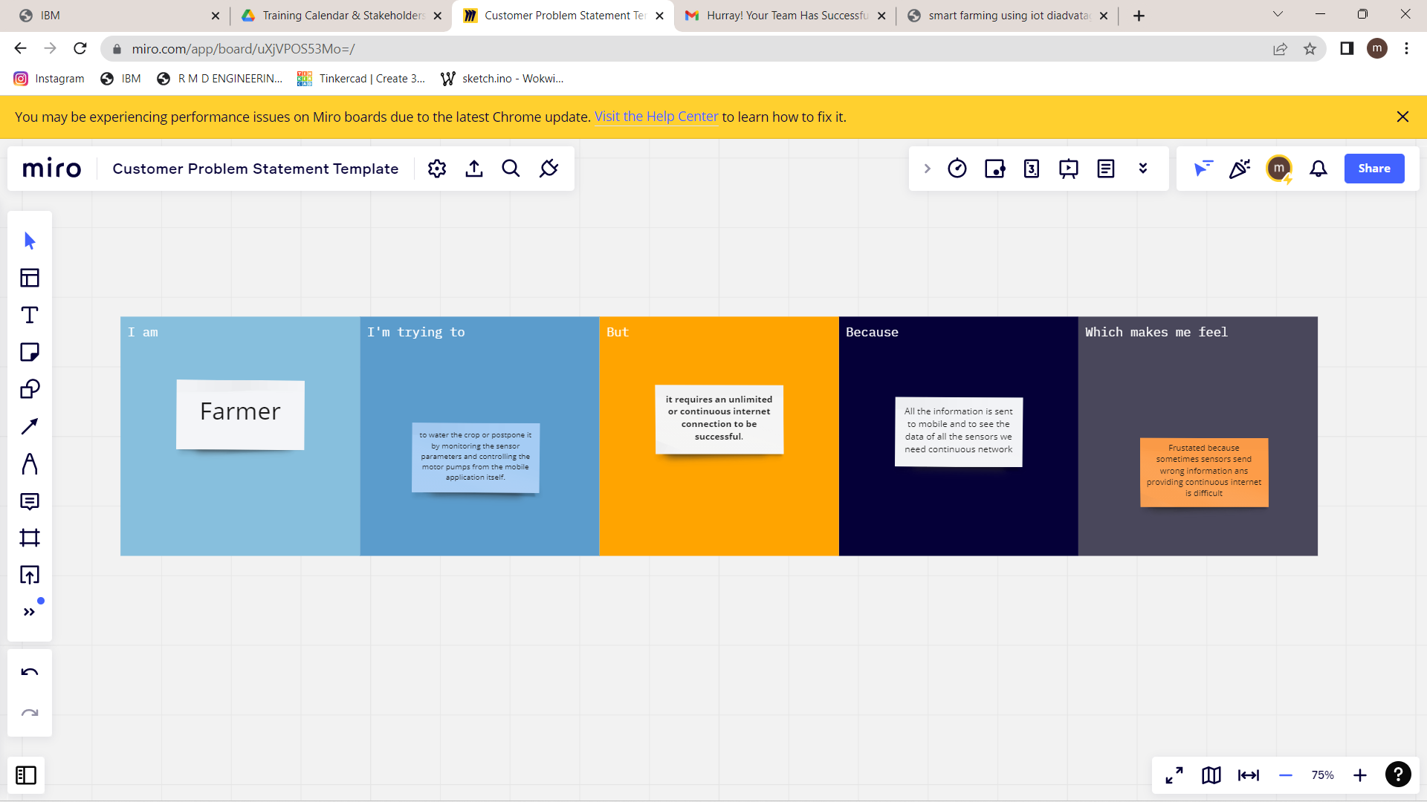

|  |  |  |  |  |  |
| --- | --- | --- | --- | --- | --- |
| **Problem**  **Statement (PS)** | **I am**  **(Customer)** | **I’m trying to** | **But** | **Because** | **Which makes me feel** |
| PS-1 | Farmer | to water the crop or postpone it by monitoring the sensor parameters and controlling the motor pumps from the mobile application itself. | **it requires an unlimited or continuous internet connection to be successful**. | All the information is sent to mobile and to see the data of all the sensors we need continuous network | Frustated because sometimes sensors send wrong information ans providing continuous internet is difficult |